# Hen game

## Breif story

This game is a hunting game where we have four variables gun,bullet,hen. Here we are playing as a huntsman and hunting for the hen.

## Goal

We all have played the old hen game in the old conosoles which we used to connect our old t.v’s and play. My game have a goal to remake the hen game by improving it .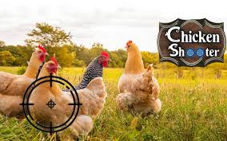

# Mechanism

Now let’s move forward to mechanism of my spectacular game!

Here we will have foue variables(gun,bullets,hen).from which we will play from the gun and we will be able to control it by our mouse,and when we press space the bullets should start moving toward right.Wehn the bullets touches the hen then the hen will be destroyed and our score will increase.

I will also add some difficulty to this game that is after very 10 score the speed of hen will increase.

